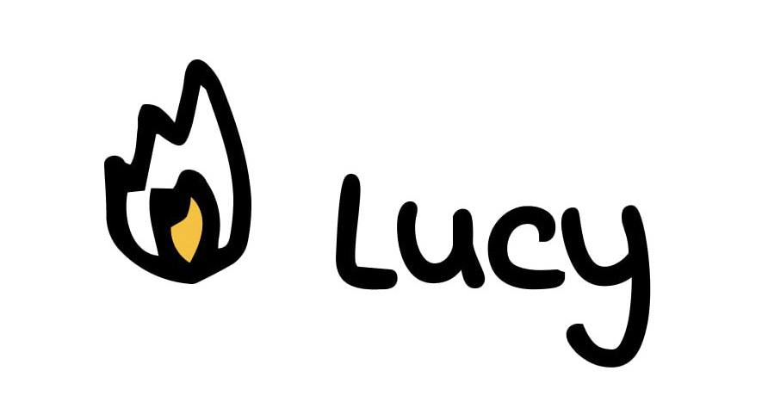

**Code, Create and Connect**

Final Project

**Name:**Simon**_**Getachew**_____________________________________________**

**Title of Project:**

Basic tools**_____________________________________________**

**Type of Project: __**Web**_____________________________________________**

1. **Project Overview**

* Give a brief summary of what your web project aims to achieve.
* My project aims to achieve making people’s life easier.

1. **Project Description:**

* Explain its main features, functionality, and the problem it solves.
* My project can help make the user’s life more convenient and time and man-power saving.

1. **Describe the technologies used?**

* This can include HTML, CSS or any other tool you employ.
* I’ve used HTML and CSS but mostly JavaScript.

1. **How many pages will your website have? And what are they?**

* My website has 4 webpages, which are **Temperature Converter**, **Password Generator**, **To-Do List** and **Pomodoro Timer**.

1. **Can you describe the steps you will take to make your project?**

Step 1: Styling the HTML file roughly.

Step 2: Coding the JavaScript file.

Step 3: Finally fully styling the webpages.